Toolkit for inclusive teaching strategies

How to set up inclusive interactions

Module 4

Module 4: How to set up inclusive interactions

🏁 Start here!
You have six sections to complete in Module 4:
- Introduction
- Principle 1: Include collaboration
- Principle 2: Help learners interact more easily with the learning materials
- Principle 3: Balance ‘listening’ and ‘doing’
- Apply the strategies
- Put it into practice
Then we recommend you set up a group discussion to:
- Reflect on the module

✏️Before you begin, we recommend that you get yourself a notebook for taking notes as you work through the toolkit.

Introduction
What’s Module 4 about?

Case study
Before we start, read the case study about Olivia. Do you have any students like Olivia in your classes?
👤 Olivia usually dreads the end of term projects, as she struggles with getting her ideas down.
But this term, her teacher put Olivia into a team with two other students. Olivia researched the ideas and shared back with her team. After a group discussion, her teammate wrote out the detailed part and Olivia took responsibility for presenting in front of the class.
Olivia really enjoyed this project because she felt useful and valuable.

💭 Why do we need to set up inclusive interactions?
One way we can think about ‘learning’ is as a series of interactions. In the online classroom, your learners interact with:
- you (the teacher)
- other learners
- the learning materials
- as a whole classroom.
All of these interactions contribute to a learner feeling successful in the online classroom. In this module we’ll look at how to set up your online environment to allow for more inclusive interactions. The strategies in this module are especially helpful for learners with executive function challenges who, like Olivia, may benefit from group work.

✏️ Are you ready to start?
Take out your notebook. As you go through this module, take notes on:
- What inclusive strategies you already use
- Why we recommend these strategies
- What other small improvements you can make to create a more inclusive practice in your classroom

Principles and strategies
Read three principles that help create more inclusive interactions in the classroom.

Principle 1: Include collaboration
✏️ Before you begin this section make a note on the following questions:

- Can you think of an example where you worked well in a team?
- What made that collaboration successful?

What is this principle?
Collaboration allows learners with different abilities and strengths to support the development of each other. This could be in pairs or larger groups.
Collaborative learning allows learners to put together their thoughts and abilities, listen actively and consider each other’s ideas and opinions.
In any type of group work, students must agree on who will handle different parts of a project and work together using each other’s strengths to complete the tasks.
How does this benefit our learners?
Group work in the classroom mimics what happens in real life. When we work in groups, we can take on different roles that suit us better. Often, more learners than we realise have low self-esteem about their abilities. Group work allows learners to explore what they’re good at, while also celebrating success as a team.
Well-structured group work can benefit:
- lower level learners who benefit from mentoring and support
- SEN students who may enjoy sharing ideas, but find reading and writing a challenge
- higher level learners by giving the opportunity to further consolidate what they’ve learned.

How can you apply this in your online classroom?
- Strategy 1: Not everyone is immediately comfortable with working in groups. Support learners by creating expectations for optimal group and peer work (e.g. participating toward the same goal, options for different roles).
- Strategy 2: Give learners sentence stems they can use to help interact as a group in English (‘Can you help me X’, or ‘Why don’t we try X?’). Share examples of positive interactions that you observe during and/or after.
- Strategy 3: Make groups with different strengths and abilities and assign clear goals, roles, and responsibilities. If possible, use break-out rooms.
- Strategy 4: Set simple tasks for learners to collaborate together. For example, review notes, study, read aloud, or complete a project like creating an online poster together on Google docs, or another online tool

🗣️​ Prepare to discuss:

- What is the layout of your online learning environment?
- How does the current layout create, or prohibit opportunities for connection and collaboration?

Principle 2: Help learners interact more easily with the learning materials
✏️ Before you begin this section make a note on the following questions:

- Have you ever been given an instruction but not been sure what you needed to do?
- Can you remember what caused this to happen?

What is this principle?
In the classroom, we often give our learners one kind of ‘input’ but expect another ‘output’ from them. For example, we might use verbal instructions to describe how we want a written task to be done.
Try using an example or a model to show what kind of output we expect. This allows all learners to understand more clearly what they need to produce.
How does this benefit our learners?
Our brains naturally vary from person to person. This means that a simple and easy task for one learner may be a huge challenge to another.
One way that we are different is in our executive functions. These are like the management system of our brain (e.g. responsible for processing and planning). By providing samples of completed work, this can help your learners to understand expectations and plan accordingly.
In any classroom there will be diversity in executive functioning skills. SEN students with ADHD or Dyslexia may show reduced ability to recall and process information. Any learner’s executive functioning could be affected by mood, fatigue, and the learning environment - meaning we all benefit by viewing samples of expected output.
How can you apply this in your online classroom?
- Strategy 1: Give learners a model or example of the task to work from that helps them to explore and understand. This can be emailed or sent in advance, or during the class.
- Strategy 2: Give learners any verbal instructions in written form. For example, copy paste your instructions into the chat box for learners to read or as you go through the task, screen share a slide with the instruction text written down.
🗣️​ Prepare to discuss:

Providing a model or sample was a solution originally designed for SEN students, however we now know that this strategy has benefits for all learners. This is an example of a solution that originally solves a problem for a minority group of learners, but has a benefit across the majority of the class.

- What other examples of this have you seen in your lessons?

Principle 3: Balance ‘listening’ and ‘doing’
✏️ Before you begin this section make a note on the following question:

- Think about a learner in a recent class who appeared bored or disengaged… What are some reasons why they may have appeared that way?

What is this principle?
When creating your lesson plans, think about the balance of interactions happening throughout. Try to balance oral presentations with visual information and activities, and passive tasks with active tasks. You should also consider the balance between large group, small group, and individual activities.
How does this benefit our learners?
Another example of an executive function is ‘working memory’. Working memory is where the brain temporarily holds any information needed for a task currently being worked on. That is, listening to, remembering, and following directions that contain multiple steps. For example, doing the steps for a recipe when no longer looking at the recipe.
By balancing listening and doing, you can respect the limits of working memory. Your learners will have the opportunity to apply new knowledge, practise new skills and reinforce their learning.
Everyone benefits from varied interactions in the classroom. As our brains can only process a certain amount of information at a time, when we are overloaded, our ability to learn decreases, and we become disengaged.
Poor working memory can affect all your learners. However, you will notice that students with SEN will particularly benefit from opportunities to directly apply new knowledge.
How can you apply this in your online classroom?
- Strategy 1: When planning the lesson, create a column to make a note of the interaction (listening, solo work, peer work, group discussion) happening at each stage. Is there a balance?
- Strategy 2: Plan your lesson starting with what you want the learners to be able to do or say at the end of the lesson. Then, review any oral teaching presentations so that you only include essential information for that task.
🗣️​ Prepare to discuss:
- Make a list of the interactions you had in your most recent lesson.
- Read your list - how many of the interactions in your classroom reflect what happens in real life?

Check your understanding
Draw a line between the principle, strategy and benefits to make groups. Include one principle, one strategy, and one benefit for each group.
Then make a note for each group with an idea of which learners in your class would benefit from this, or a challenge you see with using this strategy.
Principle |  | Strategy |  | Benefit
1. Use worked examples as part of your input and instruction to learners |  | a. Using visual aids for a short teacher-led language presentation. Then give learners a task to apply what they’ve learned. |  | a. Assist working memory by applying new knowledge immediately
2. Balance the interaction between ‘listening’ and ‘doing’ |  | b. Using break-out rooms or collaborative tools like Google docs for collaboration. |  | b. The cognitive effort needed to understand how to do the task is reduced.
3. Include collaboration |  | c. Typing or showing instructions on the screen as you say them. Showing a sample of expected work (e.g, dialogue). Send this to learners so they can process in their own time. |  | c. Learners learn from each other and experience success as a team

Answers: 1,a,b. 2,c,a. 3,b,c.

Apply to your classroom

✏️ Think about an activity that you are planning to do with your class in the next week. Make notes about:
What changes can you make to the instructions to:
- improve collaboration
- make it easier for all students to interact with the materials
- balance ‘listening’ and ‘doing’.
Make some notes to share with in your group discussion on:
- the changes you will make
- the benefits for your learners
- any challenges you see with using this strategy.

👏​ Nice work. You’re done for today! Your next task is to meet your group to discuss your ideas from the module.

Reflect on the module as a group
Welcome to your group discussion for Module 4 on inclusive interactions. This is a self-facilitated peer-learning session. Please follow the guide to go through the activities. Nominate a person for each letter A, B or C.
When it is your turn, lead the activity by reading the instructions aloud to the group and ask any questions. See below for details of each activity.
Note: The group discussion is a powerful way to share ideas and build a sense of community and accountability around inclusivity at your school. However if you’re not able to join a group discussion in your context, the activities can also be completed alone as reflection and review tasks.
Activity leader | Activity name | Time
Teacher A | Check in and introductions | Five minutes
Teacher B | Group review | Ten minutes
Teacher C | Group reflection | 15 minutes

Check in and introduction - led by Teacher ‘A’
Before you begin, prepare for the session with a short ‘check in’. A check in is a short pause at the beginning of a meeting to reflect on how you feel at this moment.
It might be that you have just had a very stressful class, or maybe you were running late today and feel in a rush. Sharing with the group helps to build empathy. When we have shared we are ready to begin the discussion.
Take a moment to look at the picture with the different fish. Choose a fish that represents how you are feeling today. Then, introduce yourself: tell the group your name and share which fish you have chosen and why. Spend about five minutes on this section.
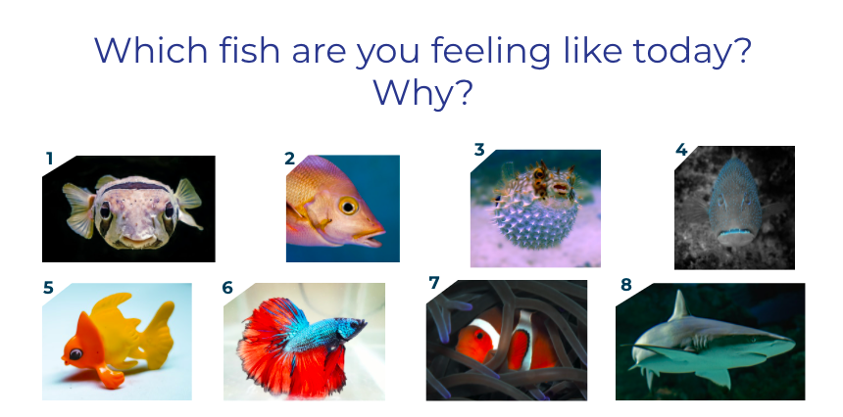

Review - led by Teacher ‘B’
Choose a strategy and take turns and tell each other one or two things about this strategy. Spend about ten minutes on this section.
- Collaboration
- Using worked examples
- Balance ‘listening’ and ‘doing’
For example:
Do you have any more examples of how this principle can be applied in the online classroom?
Have you used any of these in your online classroom? Was it successful?

Reflect - led by Teacher ‘C’
Discuss the following reflection questions from the module as a group. Spend about 15 minutes on this section.
- What is the layout of your online learning environment? How does the current layout create, or prohibit opportunities for connection and collaboration?
- Providing a model or sample is a solution originally for SEN students, however we now know that this strategy has benefits for all learners.
This is an example of a solution that originally solves a problem for a minority group of learners, but has a benefit across the majority of the class. What other examples of this have you seen in your lessons?
- Make a list of the interactions you had in your most recent lesson. Read your list - how many of the interactions in your classroom reflect what happens in real life?

💻​ If you’re interested in this topic check out the links for further reading:
- www.youtube.com. (n.d.). Kat Holmes: Rethink What Inclusive Design Means. [online] Available at: https://www.youtube.com/watch?v=-iccWRhKZa8.
- Duckworth, A. (2021). Why Teamwork in Class Builds Competence and Confidence (Opinion). [online] Education Week. Available at: https://www.edweek.org/teaching-learning/opinion-why-teamwork-in-class-builds-competence-and-confidence/2021/02.

